Which is healthier from a cash flow standpoint, Sears or Wal-Mart?
Sears Holding Corporation (SHLD) announced in April 2016 that it would be closing 68 Kmart and 10 Sears stores during the second half of 2016. The stores it is closing have not been profitable for Sears and it is looking to improve profitability with the closures.
Similarly, Wal-Mart Stores, Inc., (WMT) announced in January 2016, that it would be closing 269 stores worldwide. Again, this move is an effort to increase profitability for Wal-Mart.
Sears’ fiscal year-end is the Saturday closest to January 31. Below are its statement of cash flows for the most recent three years.
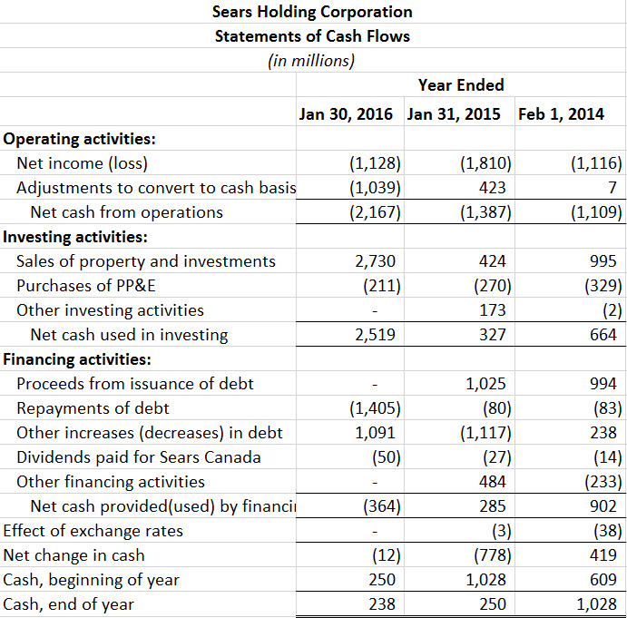

Wal-Mart’s fiscal year-end is January 31. Below are its statements of cash flows for the most recent three years.
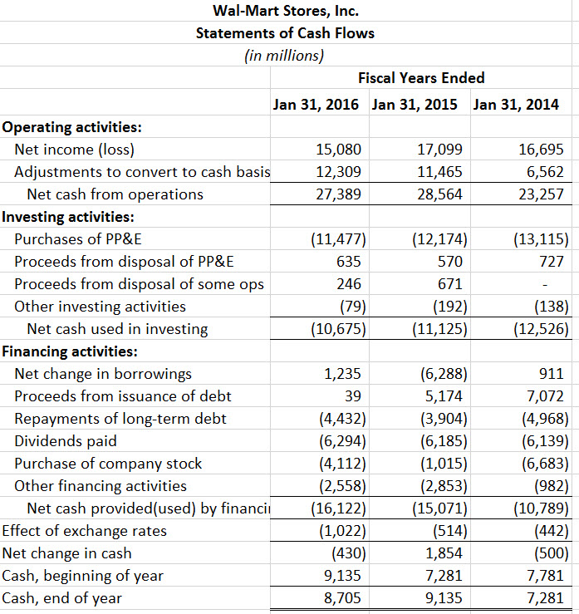

Questions
- Using its statements of cash flows, answer the following questions about Sears:
  - Is Sears generating cash from its operations?
  - Describe what investing activities Sears has been involved in over the past three years. Are investing activities an overall source or use of funds for Sears?
  - What financing activities has Sears been undertaking in the past three years? Has it been paying dividends to its common stockholders? (Note: Sears Canada is a holding that does not represent Sears common stockholders.)
  - How will the closure of the Kmart and Sears stores impact the 2016 statement of cash flows?
- Using its statements of cash flows, answer the following questions about Wal-Mart:
  - Is Wal-Mart generating cash from its operations?
  - Describe what investing activities Wal-Mart has been involved in over the past three years. Are investing activities an overall source or use of funds for Wal-Mart?
  - What financing activities has Wal-Mart been undertaking in the past three years? Has it been paying dividends to its common stockholders?
  - How will the closure of the Wal-Mart stores impact the 2016 statement of cash flows?
- Judging from the statements of cash flows, which company, Sears or Wal-Mart, is healthier?
- Why do you think Sears and Wal-Mart would have fiscal year-ends around January 31 rather than using a calendar year-end of December 31?

