

What does Kohl’s 2015 Form 10-K communicate about its stockholders’ equity?
Kohl’s Corporation (KSS) operates department stores in 49 states in the U.S. and has annual sales in excess of $18 billion. Its fiscal year ends on the Saturday closest to January 31 each year.
Kohl’s has several line items comprising its stockholders’ equity. See the excerpts to follow from Kohl’s 2015 Form 10-K: its Consolidated Balance Sheets, an enlarged partial Consolidated Balance Sheet (page F-3), its Consolidated Statements of Changes in Shareholders’ Equity (page F-5), and a section from its Notes to Financial Statements (page F-8). All of these statements are included at the bottom of this post.
Questions
- Why would a fiscal year end of “the Saturday closest to January 31 each year” make sense for Kohl’s?
- What types of stock is Kohl’s authorized to issue? How many shares of each type are authorized to be issued?
- Approximately how many shares of common stock had been issued as of January 31, 2015?
- Approximately how many shares of common stock were outstanding as of January 31, 2015? (Hint: You will need to calculate this number.)
- Why is treasury stock shown as a negative on the balance sheet?
- Has Kohl’s accumulated earnings to date exceeded its accumulated losses and dividends declared to date? How do you know?

Kohl’s Corporation Consolidated Balance Sheets from p. F-3 of Form 10-K as of January 31, 2015:
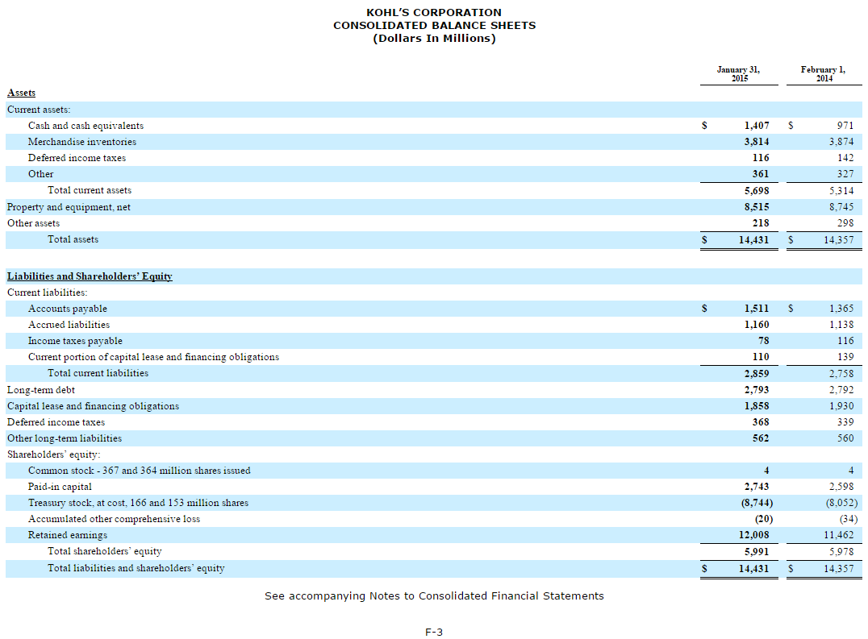
Kohl’s Corporation Consolidated Balance Sheets from p. F-3 of Form 10-K as of January 31, 2015 (enlarged Shareholders’ Equity section):
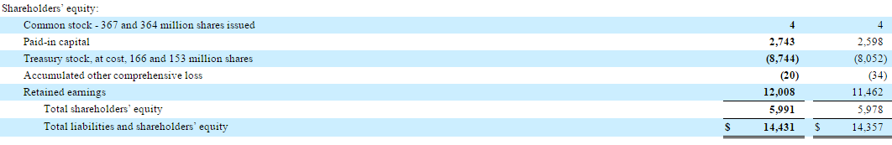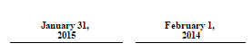

Kohl’s Corporation Consolidated Statements of Changes in Shareholders’ Equity from p. F-5 of Form 10-K as of January 31, 2015:
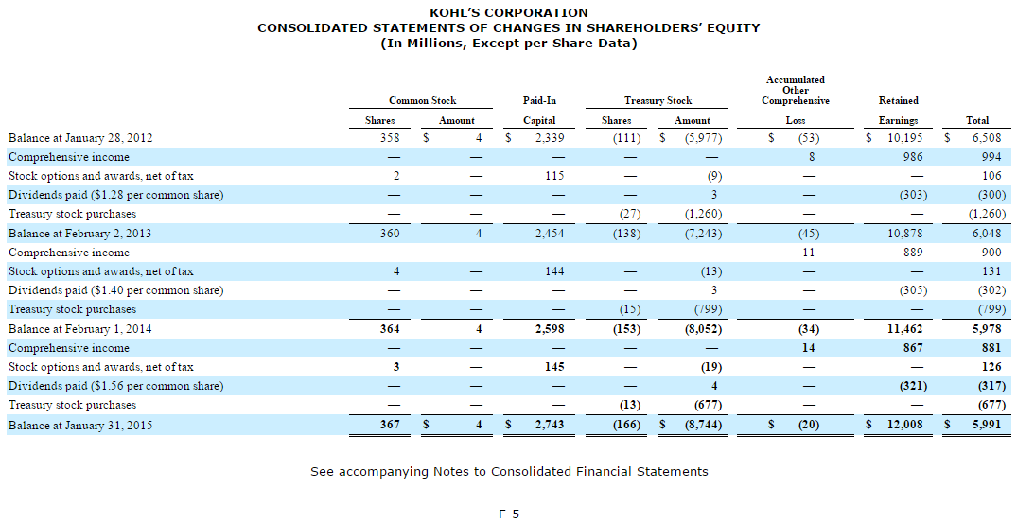

Excerpt from Notes to Financial Statements on p. F-8 of Form 10-K as of January 31, 2015:
