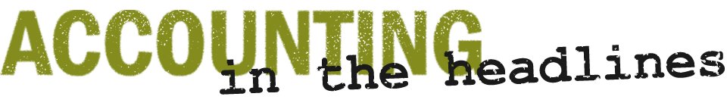

What information is in the auditor and management letters in The J.M. Smucker Company’s Form 10-K?
The J. M. Smucker Company (SJM) was started in 1897 by Jerome Monroe Smucker in Orrville, Ohio. The J. M. Smucker Company has several well-known brands in its lineup, including Jif, Folgers, Pillsbury, and Hungry Jack.
Since The J. M. Smucker Company is publicly-held, it issues a Form 10-K each year. It is also required to have an audit each year.
See the following excerpts from The J. M. Smucker Company’s Form 10-K for 2014:
- Report of Independent Registered Public Accounting Firm on Internal Control over Financial Reporting (page 36);
- Report of Independent Registered Public Accounting Firm on the Consolidated Financial Statements (page 37); and
- Report of Management on Responsibility for Financial Reporting (page 38).
Questions
- What is management’s responsibility related to the financial statements and related financial information in the Form 10-K?
- Who is Smucker’s independent audit firm? What is the auditor’s responsibility related to the financial statements and related financial information in the Form 10-K?
- What does an internal audit department do?
- Does the audit guarantee that the financial statements are completely correct? How do you know?
- Why is the auditor’s report important to an investor?

Source: The J.M. Smucker Company, Form 10-K, June 23, 2014, page 36
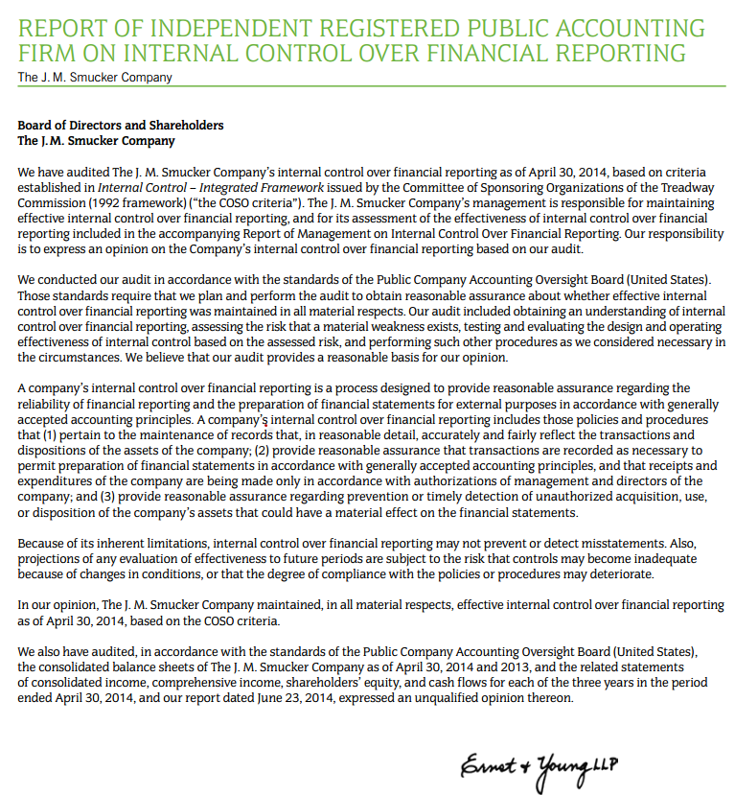

Source: The J.M. Smucker Company, Form 10-K, June 23, 2014, page 37
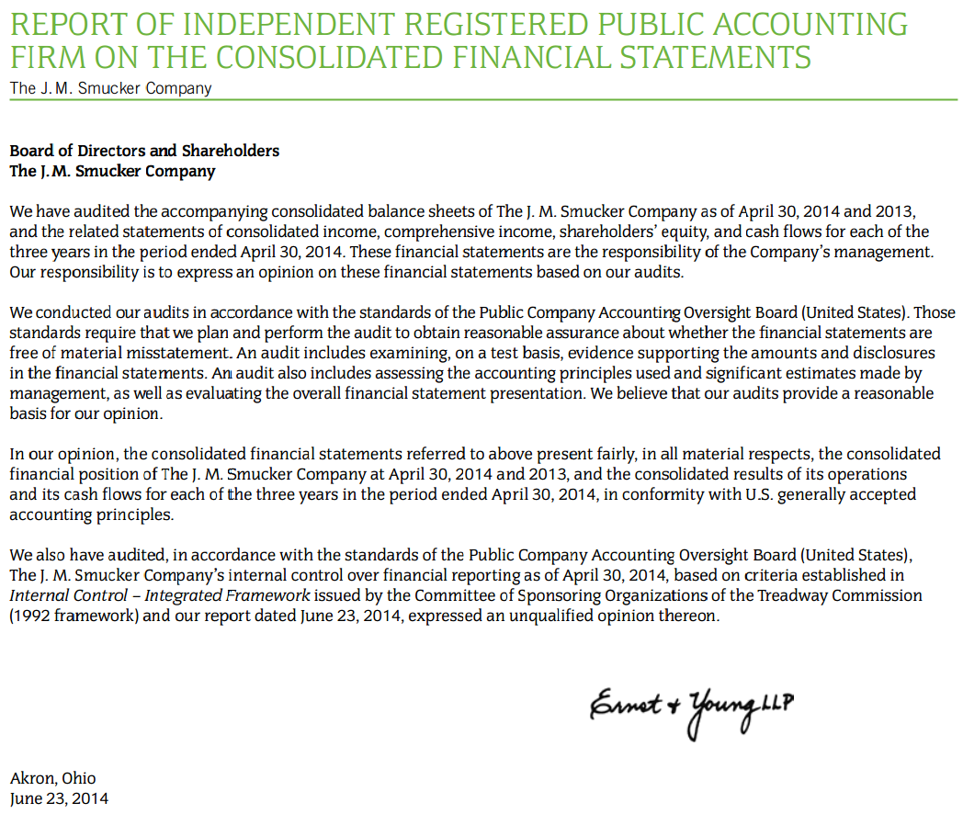

Source: The J.M. Smucker Company, Form 10-K, June 23, 2014, page 38
