

What does Coca-Cola’s Form 10-K communicate about its accounts receivable?
The Coca-Cola Company (KO), like other U.S. publicly-held companies, files its financial statements in an annual filing called a Form 10-K with the Securities & Exchange Commission (SEC).
Coca-Cola has several assets that are listed on its balance sheet. Let’s look at what is reported on Coca-Cola’s Form 10-K regarding its accounts receivable.
See the following excerpts from Coca-Cola’s 2013 Form 10-K:
- Partial Consolidated Balance Sheets containing current assets (page 76);
- Trade Accounts Receivable note (page 89); and
- Partial Statements of Income (page 74).
Questions
- What is the total (gross) value of Coca-Cola’s accounts receivable (before deduction for its allowance for doubtful accounts) as of December 31, 2013? As of December 31, 2012?
- What is “net realizable value”?
- What factors does Coca-Cola use to determine the amount of its allowance for doubtful accounts?
- In what line item on the income statement would bad debt expense be included?

Partial balance sheet (assets) from p. 76 of Form 10-K as of December 31, 2013:

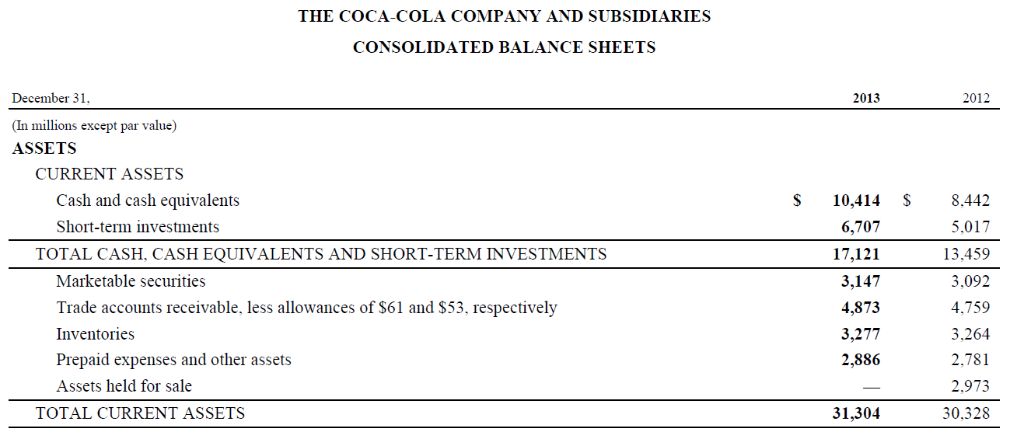

Partial note from p. 83 of Form 10-K as of December 31, 2013:

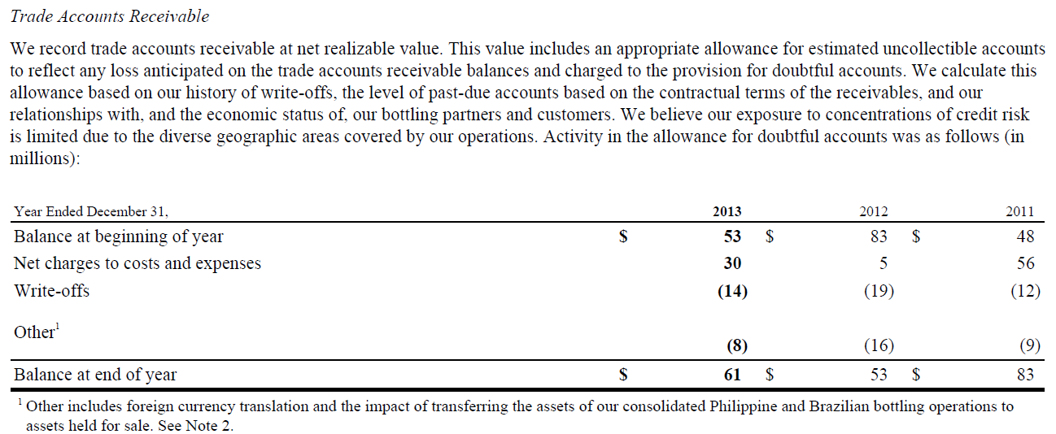

Partial notes from p. 74 of Form 10-K as of December 31, 2013:

